|  |
| --- |
|  |
|  |

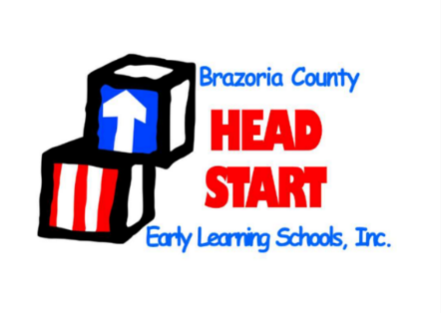

Approved by Policy Council: 02/26/2024

Approved by Board: 03/05/2024

Annual Report

2022 – 2023

Brazoria County Head Start

Early Learning Schools, Inc

651 W Miller St 979-849-1881

Angleton, TX 77515 [www.headstartbc.org](http://www.headstartbc.org)

Brazoria County Head Start Early Learning Schools, Inc. (BCHS) is a nonprofit 501 (3)(c) organization that has served the children and families in Brazoria County since 1975. BCHS operates three campuses throughout Brazoria County, one of which is accredited by the National Association for the Education of Young Children (NAEYC). BCHS is a comprehensive birth-to-five program, that serves infants, toddlers and preschoolers; employs a staff of 50 that provides school readiness for children, as well as self-sufficiency and stability support for parents, families and caregivers.

Brazoria County Head Start Early Learning Schools, Inc., exists to provide case management and school readiness for families and children to foster self-sufficiency and family stability while simultaneously ensuring social, emotional, cognitive, physical and moral mastery for each child.

**Our Mission**

Table of Contents

Campus Information & Locations 4

Board of Directors and Policy Council 5

Message from the President & CEO 6

Financial Data 7

Legacy Fund Drive 8

2023 Raffle Prize Donors 9

Program Enrollment & Information 10

Health & Disability Services 10

Family Engagement 10

Comprehensive Services to Families 11

School Readiness 11

Staff Education Demographics 13

Community Partners 13



# Campus Information & Locations

|  |  |  |
| --- | --- | --- |
| **Angleton Campus**  Funded Enrollment – 59  Principal: Tamara Fisher  (979) 849-9261 | **Brazoria Campus**  Funded Enrollment – 89  Principal: Brenda Tinsley  (979) 798-2391 | **Lake Jackson Campus**  Funded Enrollment – 57  Principal: Cabrienna Gardner  (979) 297-8018 |

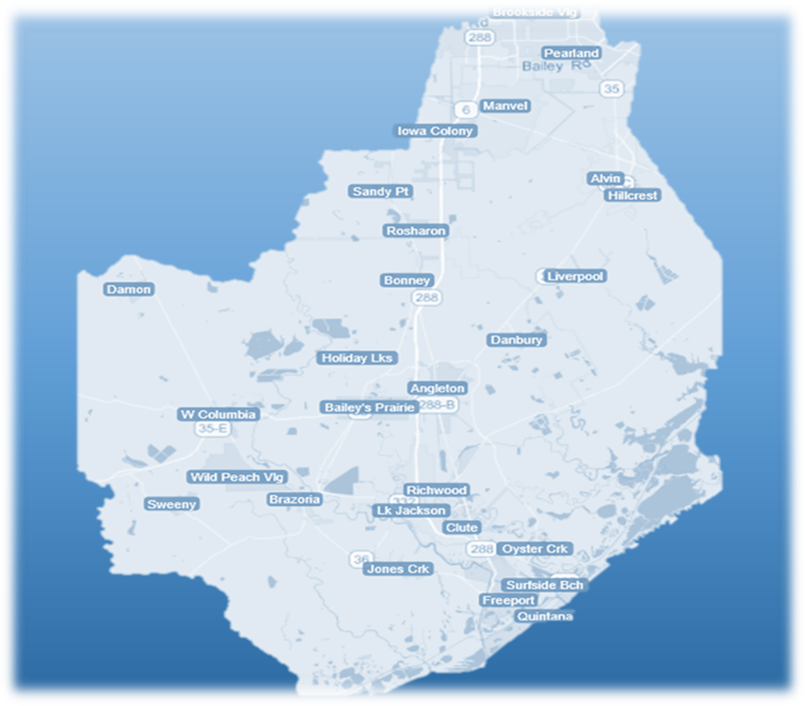

# Board of Directors and Policy Council

Ester Williams – Chair

Cindy Massoletti – Vice Chair

Carrie Robertson – Treasurer

Vicki Harmon – Secretary

Dodie Armstrong

Luis Cruz

Teresia Green

Jennifer Kelly

Gerald Roznovsky

Jeannetta Williams

Bob Garcia – Chairman of the Board Emeritus

Tommie Calderon

Terry Comingore – Treasurer Emeritus

Carol Bertholf

Barbara Fratila

Erica Flores

**Officers**

**Board of Directors**

Alex Ingham

President

Yazmine Guzman

Vice President

Jessica Jimenez

Secretary

Yessica Espinoza

Ocean Geolge

Jessica Holloway

Karla Monroy

**Alternate Members**

Kelly Aaron

Tamaria Campbell

Leticia Cervantes

Christina Guajardo

Gabriel Cuellar

Brady Holloway

Taylor Horn

Virginia Lopez

Elizabeth Martinez

Delores Olivares

Nicole Ward

Gabriella Montalvo

**Policy Council**

**Directors**

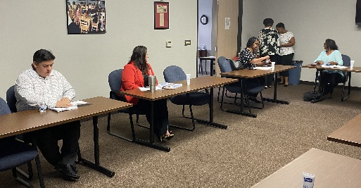

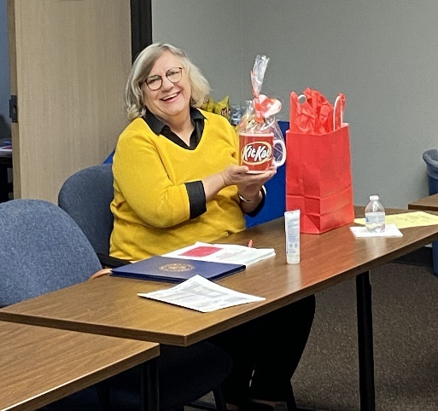

**Ex Officio Members & Consultants**

# A person smiling at the cameraA person smiling for a picture Description automatically generatedMessage from the President & CEO

Greetings,

It gives me great pleasure to share with you our 2022-2023 Annual Report that provides data which reflects another great and successful year.  For the past 50 years, Brazoria County Head Start Early Learning Schools Inc. (BCHS) has been at the forefront of providing high quality comprehensive early childhood services to children and families. BCHS sponsors both the Head Start and Early Head Start Programs in Brazoria County and relishes being a high-performance company with well-qualified, committed and dedicated staff; a supportive Board of Directors; an active Policy Council; and appreciates the endorsement of elected officials and community leaders, along with an abundance of volunteers over the past 50 plus years.

BCHS strives to support the needs of families and build the academic and social foundations of every child that comes into our program. The health and safety of the staff and children continues to be a top priority, and BCHS strives to provide a positive work environment. Our staff is committed to making a difference in each student’s life while providing the best services possible.

BCHS remains committed to excellence in all we do by providing children and families with the skills needed to be ready for the demands of school and their future success. Together we will have a lasting impact on their lives. BCHS serves economically disadvantaged children from birth to five years of age and their families, has a current enrollment of 205 children, and three schools located in the cities of Angleton, Brazoria, and Lake Jackson. We also have classrooms on the Columbia-Brazoria ISD Wild Peach Pre-K campus through a dual enrollment partnership.

We are pleased to share with you some highlights of our programs, and I hope you enjoy our Annual Report.

Sincerely,

**Jacqueline Mercer, Mercer**

President & CEO

# Financial Data

The financial information on this page was obtained from our most recent audited financial statements for the fiscal year ending June 30, 2023. BCHS received an unmodified (clean) audit report. A complete set of our audited financial statements are available to the public at our Administrative Office located at 651 West Miller, Angleton, Texas 77515.

|  |  |  |  |  |
| --- | --- | --- | --- | --- |
| **Audited Financial Information**  **2022-2023** |  |  | **Budget Information Fiscal Year**  **2023-2024** |  |
| Total Revenue | $2,985,621 |  | Revenues |  |
| Public Funds from Governmental Grants and Fees |  |  | Dept of Health & Human Services—Head Start & Early Head Start | $2,573,464 |
| U.S Department of Health and Human Services Head Start | $2,572,738 |  | Texas Department of Agriculture—Child & Adult Care Food Program (CACFP) | $118,000 |
| Texas Department of Agriculture Child & Adult Care Food Program | $114,885 |  | Other Income | $0.00 |
| Private Funds from Contributions and Other Income |  |  | In-kind Contributions  (Donated Services) | $595,028 |
| Donated Services and Facilities | $646,318 |  | Total Revenues | $3,286,492 |
| Unrestricted Contributions | $2,444 |  | Expenditures |  |
| Raffle Sales, Net of Expenses | $13,422 |  | Personnel Costs | $1,581,098 |
| Interest Income/Other Income | $2,484 |  | Fringe Benefits | $254,271 |
| Expenses for Fiscal Year Ending June 30, 2022 | $3,108,146 |  | Travel Out of Area | $8,127 |
| Total Net Asset at June 30, 2022 Net of Accumulated Depreciation | $1,531,295 |  | Capital Equipment | $24,590 |
| Liabilities | $126,047 |  | Small Equipment | $25, 049 |
|  |  |  | Supplies | $52,296 |
|  |  |  | Contractual | $232,500 |
|  |  |  | Facilities/Construction | $0.00 |
|  |  |  | Other | $513,533 |
|  |  |  | In-kind Expenses  (Donated Services) | $595,028 |
|  |  |  | Total Expenditures | $3,286,492 |

# Legacy Fund Drive

The Legacy Fund Drive was launched in the fall of 2007 for the purpose of establishing an endowment that will secure and sustain BCHS’s legacy of providing quality educational services for preschool children throughout Brazoria County in the years to come. The company thanks the following donors for their cumulative donations.

BCOS Office Technologies

Colley Refrigeration

Greg Flaniken & Associates

Finley & Neal P.C.

Dr. Alfredo & Sylvia Flores

Gulf Coast Auto

Kaplan Early Learning Co.

Kennemer, Masters & Lunsford, LLC

Kiwanis Club of Alvin

Lawrence Wrecker Service

Liz Plaster Companies LLC

Juan Martinez, Jr. Memorial

Darry & Jacqueline Mercer

Nate & Evelyn Moore

R&M Telephone

Ron Carter Autoland

Dr. Sandra Rouce

Gloria Smith RD, LD

Dorothy Thomas MS, RD, LD

Adelaide Thorpe

Anonymous Donors

BASF

TDEC, Inc/Eileen Mancil

E. Williams Enterprises, LLC

Platinum Donor ($500-$2,999)

# 

Dr. Diana Bazan

Dr. Carrie A Brown

Innovative Mobile Therapy, LTD.

Brandei Goolsby

Neal Insurance Agency

Earl & Zenia Shipp

Carmage & Martha Walls Foundation

J Walker Enterprises

Wal-Mart

Wells Fargo Bank

Wipfli

Ambassador Donor ($3,000+)

Jim Isom

Ruby Jackson

One Stop Bus Stop

Kathy Pickering, RN

Raggedy Jan’s

Daniel Leal

Mr. & Mrs. T.J. Wright, Jr.

Emeraldo Falcon Jr. M.D.

Barbara P Fratila, JD

Bronze Donor

($1-$99)

Judge Ogden Bass

Brazosport Foods

J&H Energy Consultants

Terry & Linda Comingore

Rev. & Mrs. L.C. Dews

Bob & Jane Garcia

Rev. & Mrs. Larry Griggs, Sr.

Gulf Fence Company

Michael & Ann O’Hara

Shelly Patterson

Sardelich Counseling & Consulting

Frances Schneider

Esther Williams

Gold DOnor

($300-$499)

# 

Alarm Masters

Gary & Rhonda Cloudt

Ronald & Judy Courts

Family Practice Associates

Dr. Rogers & Dr. Veselka

N.J. Landry, Sr.

Cheryl Wright Kennedy

Law Office of Atty Faye Gordon, PLLC

Dr. Elizabeth Walker

Jim & Jo Wiginton

Lillie Bell Wright Memorial

Mr. L.C. Wright & Family

Thomas J Sr. & Martha Wright memorial

Arthur Velasquez

John & Beverly Widders

Floyd Henderson

Silver DOnor

($100-$299)

2023 Raffle Prize Donors

# A logo of a baseball teamA yellow and red sign with blue textA cartoon of a person riding a crocodileA logo for a insurance companyA blue and white texas map with a cross Description automatically generatedA sign from a ropeA silhouette of a shipA close-up of a logoA green and white text on a black backgroundA logo for a health networkA white cloud with blue text Description automatically generatedA blue and green logo Description automatically generatedProgram Enrollment & Information

A special thanks to ALL our 2023 raffle prize donors for your generous donations.

|  |  |
| --- | --- |
| Prosper Nutrition | Barty Brown |
| Eileen Mancil/TDECU, INC | Linda Thomas |
| Frederick & Ashley Austin | Alvin’s Restaurant |
| Miss Jessies Craft Corner | Sweet Kutz Barber Shop |
| Zeola’s Fashions | Georgia Petteway |
| Brenna’s Wreath World | James Ellis Auto Sales |

26,000+

Preschool Children, Toddlers and Pregnant Clients have been served in Brazoria County over the last 40+ years.

**Average Monthly Attendance**

**BCHS is required to maintain an 85%**

**ADA Monthly.**



**2022-2023 Funded Enrollment**

* BCHS was funded for 205 Children.
* 179 families participated in the program.
* BCHS is serving 37% of eligible children in Brazoria County based on the Community Assessment.

**2022**

**2023**

# Health & Disability Services

The health of BCHS children is one of our primary concerns. We provide and/or partner with local agencies to deliver comprehensive services that include preventive screenings and exams such as, immunizations, physical and dental exams, vision and hearing screenings, as well as developmental and mental health screenings). We work closely with families to ensure they identify a medical support service within the community to ensure accessible, continuous, comprehensive, and family centered medical care for years to come.Family Engagement

BCHS is an exceptional place for all children including those with special needs. We are committed to working with families and the local ISD’s to ensure that the children, including those with disabilities, receive the comprehensive services they need to meet their developmental, health, and social needs. In addition, we are also committed to continuously meeting the mandated 10% of enrollment opportunities for children with disabilities.

11.7% Disabilities

91.6% Dentals

97.2% Health Insurance

93.9% Medical Home

Family Engagement in Head Start and Early Head Start is about building relationships with families that support family wellbeing; supporting strong relationships between parents and their children; and nurturing ongoing learning and development for both parents and children. The Parent, Family, and Community Engagement (PFCE) Framework is a roadmap for progress in achieving the types of outcomes that lead to positive and enduring change for children and families.

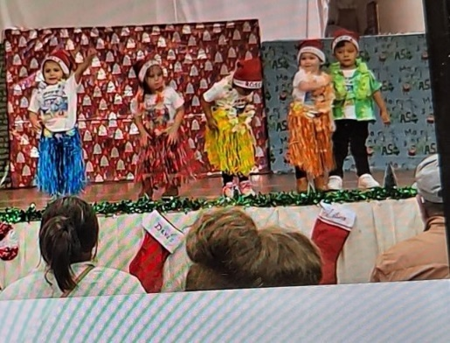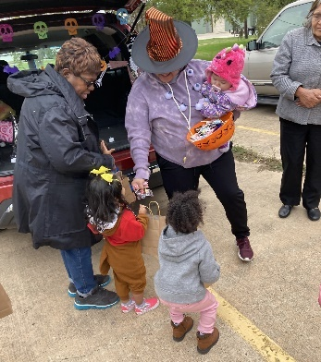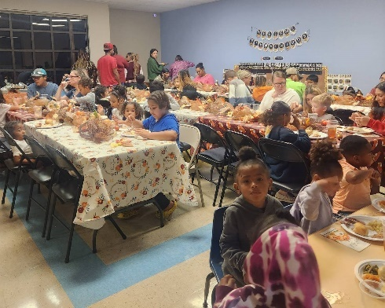

We offer several opportunities for Family Engagement that include Family Literacy Night, The Fatherhood Program, Monthly Parent Meetings, ARK (Adults Relating to Kids), Family Values Night, Parent Expo, Valentines Dance, and volunteering opportunities.

# Comprehensive Services to Families

# A stethoscope on a computer Description automatically generatedA black and yellow sign with a child holding hands Description automatically generatedA red exclamation mark in a circle Description automatically generatedA drawing of a cube with a white arrow Description automatically generatedSchool Readiness

**Health Education**

**26**

**147**

**202**

**117**

**138**

**Education on Nutrition**

**Assistance in enrolling into an education or job training program**

**Parenting Education**

**Emergency/Crisis Intervention**

BCHS is a high-quality birth to five early learning school with an educational goal that ensures children are ready for school, and families are ready to support their children’s learning. BCHS continues to be an early childhood trailblazer with a solid, clear, and inclusive focus on all facets of healthy development, including physical, cognitive and social/emotional development; all the ingredients to ensure children are school ready.

BCHS’s School Readiness is accomplished and maintained with a three-pronged approach:

1. Hiring high quality and qualified Head Start Teachers that have an associate of art or bachelor’s degree in early childhood education and Early Head Start Teachers with a minimum of an Infant Toddler CDA.

2. NAEYC Accredited Campuses.

3. A brain research-based curriculum which is aligned with the Head Start Early Learning Frameworks and the State of Texas Pre-K Guideline. BCHS utilizes the Creative Curriculum which prepares children for success in school and life with the leading research-based, whole-child preschool curriculum built for early childhood educators.

BCHS’s children are assessed with Child Plus DRDP Child Outcomes at the beginning (BOY), middle of the year (MOY) and the end of the year (EOY). Please refer to the table below for the end of year scores.

The Classroom Assessment Scoring System (CLASS) is an observation instrument that assesses the quality of the teacher-child interactions in campus based preschool classrooms. CLASS includes three domains or categories of teacher-child interactions that support children’s learning and development: emotional support, classroom organization and instructional support.

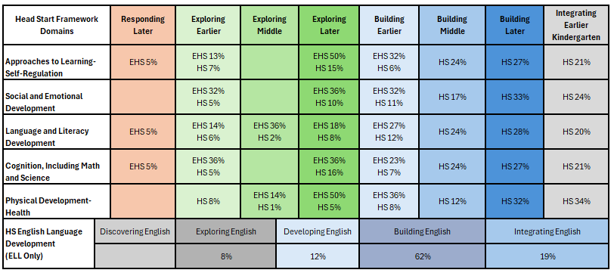

**2022-2023 End of Year Child Outcomes**

# 2022 – 2023 Staff Education Demographics

BCHS has a highly dedicated, well-qualified staff; 25% of our staff were current or former Head Start Parents; 12 % were Head Start graduates, our staff has a combined total of over 400 years of teaching/HS experience, and over 100 hours of professional development were completed by staff.

**Angleton Campus**

**Admin Staff**

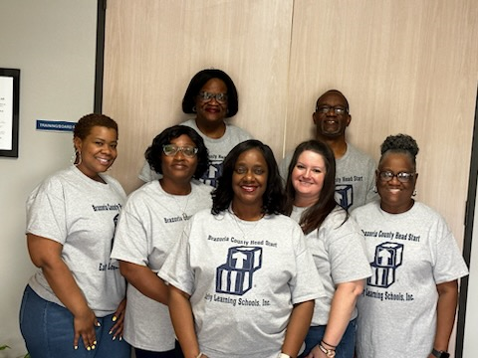

**Brazoria Campus**

**Lake Jackson Campus**

# A blue and white rectangular sign with a person in a circle and a hand Description automatically generatedA blue and green logo Description automatically generatedA logo for a library Description automatically generatedA screenshot of a computer Description automatically generatedA logo for a company Description automatically generatedA black and blue sign with white text Description automatically generatedA computer screen shot of a website Description automatically generatedCommunities In SchoolsAngleton Independent School District LogoA close-up of a sign Description automatically generatedCommunity Partners

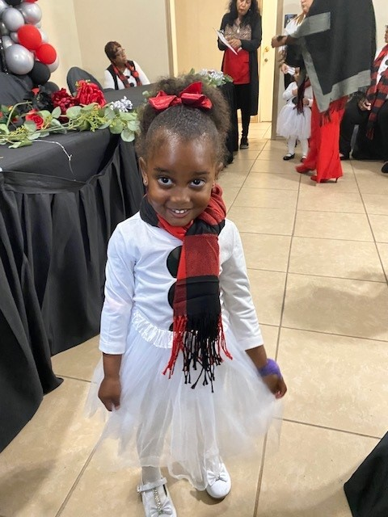

Brazoria County Head Start Early Learning Schools, Inc.

651 West Miller Street Angleton, TX 77515

|  |  |
| --- | --- |
| (979) 849-1881 | www.headstartbc.org |

Jaqueline Mercer

President & CEO